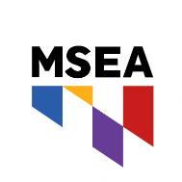

**MSEA FUND FOR CHILDREN AND PUBLIC EDUCATION**

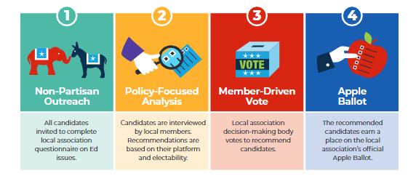

**How We Endorse**

**Our Candidates**

The NEA, MSEA and applicable local Funds for Children and Public Education collect voluntary contributions from Association members and use those contributions for political purposes, including but not limited to making contributions and expenditures on behalf of friends of public education who are candidates for federal, state, or local office. I understand that I am making a joint contribution and that ten (10) percent of my contribution will go to the NEA Fund, and that the remaining ninety (90) percent will be divided evenly between the MSEA Fund and the local account. Contributions to the Fund are voluntary; making a contribution is neither a condition of employment nor membership in the Association, and members have the right to refuse to contribute without suffering any reprisal. A member may contribute more or less than the suggested amount, or not contribute, without affecting his/her membership status, rights, or benefits in NEA, MSEA, or any of MSEA's affiliates.

Contributions to the Fund are not deductible as charitable contributions for Federal or State income tax purposes.

Federal law requires us to use our best efforts to collect and report the name, mailing address, occupation, and name of employer for each individual whose contributions aggregate in excess of $200 in a calendar year. Only U.S. citizens or lawful permanent residents may contribute to the Fund. All donations from persons other than members of NEA and its affiliates, and their immediate families, will be returned forthwith.

With full knowledge of this information, I agree that my authorization for political action pledges as indicated by the check mark herein and my authorization for payroll deductions, shall continue in force from year to year unless revoked or modified by me giving written notice to my local association.

VOLUNTARY CONTRIBUTION AUTHORIZATION FORM

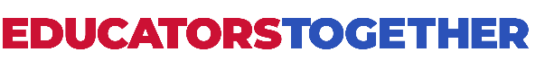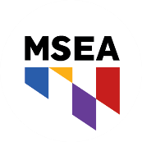

**VOLUNTARY CONTRIBUTION AUTHORIZATION FORM**

PLEASE PRINT CLEARLY

**FIRST NAME:___________________________LAST NAME:______________________________**

**COUNTY:________________________________WORKSITE:______________________________**

**PERSONAL EMAIL:________________________________________________________________**

**CELL PHONE:_____________________________________________________________________**

**CURRENT PAC CONTRIBUTION:**

❑ **I AM READY TO JOIN PAC!** We do not use our dues money to educate voters on our recommended candidates. Your PAC contributions pay for mailers, phones, and the apple ballots we use to elect pro-public education candidates.

**Payroll Deduction Per Pay Period** (please check one): **\***This new amount will replace your current contribution, **not add to it.**

 **$5**  **$15**   **$25**    $________ Other

  I agree to this voluntary, non-tax-deductible contribution & acknowledge the legal disclaimer on the back of this form.

**SIGNATURE:_______________________________________________________________**

❑ **I WILL JOIN THE GR COMMITTEE!** Please add my name to the list of educators that are willing to help organize other members and lobby elected officials.

When TAAAC members act together, we can win together. We saw that last year when hundreds of educators spoke up to advocate for higher starting salaries, better leave policies, and protections against privatization.

In 2024, our entire Board of Education is up for election. We know that to see the wage increases we deserve, and improvements to learning conditions our students deserve, we need BOE members who support educators.

Since this is only the second time voters will elect our Board of Education, we need to get out the word that these races matter and their votes are important. If we can reach these voters and talk to them about supporting pro-public education candidates, we can win.

2024 Winter Action Form