December 2022 10-minute Meeting
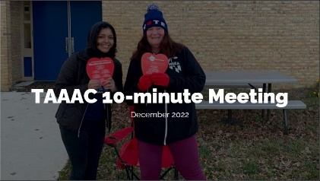 | Welcome to the December 10-minute meeting! We know you’re doing your best to make it until Winter Break, and your efforts both in our school building and across the union are seen.
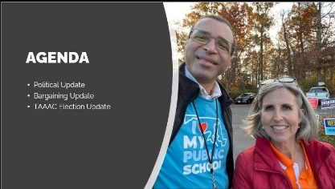 | Quick agenda review: We’ll be discussing updates in the political realm, bargaining, and with our union leadership elections!
Educators won big in the 2022 elections last month, with over 90% of our endorsed candidates taking office. Now it’s up to us to hold them accountable in supporting our advocacy for better wages and working conditions. If you are interested or concerned about any upcoming actions in the Board of Education, County Council, or on the state level (think Blueprint funding and implementation), reach out to the TAAAC Office to participate in meetings with elected officials every Monday.

Save the Date also for our annual legislative happy hour, which will be held January 7, 2023 at 5:30 p.m. at Yellowfin in Edgewater!
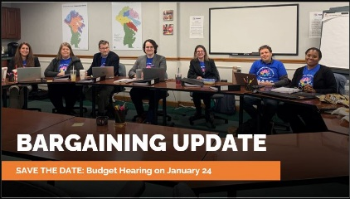 | Our Negotiations team has held two sessions so far this bargaining cycle and is optimistic about the progress they have made so far, but need the help of every one of us. We know the topics of bargaining this year can include salary, healthcare, pay for sub coverage, and Blueprint funding, so they are asking all TAAAC members to commit to one of three actions:  - Attend one of Dr. Bedell’s listening sessions to make your priorities heard  - Speak at the annual Board of Education Budget Hearing at Old Mill High School on January 24  - Join the Contract Action Team to make a plan to advocate for our bargaining priorities!
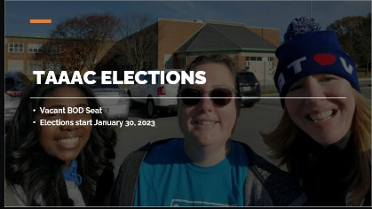 | One of the most important tasks we have as union members is conducting internal elections! Elections for our Secretary-Treasurer, five Board of Director seats, and MSEA/NEA delegates to support our work on the state and national level, will start January 30, 2023. These positions will be voted on by all TAAAC members electronically. You will receive information about voting via email.  Additionally, a sixth seat on our Board of Directors has opened up as a vacancy. If you are interested in running for this position, nominations will be accepted until January 11 at our Rep Assembly.
 | Any questions?

