10-minute meeting | November 7, 2022
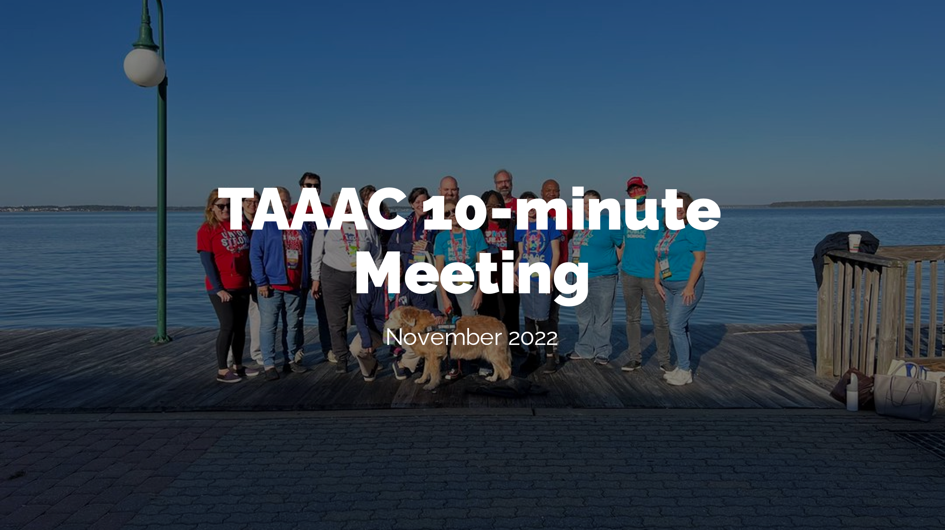 | Slide 1: Welcome to the November 10-minute meeting. Today we’ll review upcoming events to make our voices heard at, take a quick survey, and check out other updates from our union.
Slide 2: First – now that election season is over, we dive right into budget season. With inflation continuing to rise, our chance to impact our COLA and overall compensation package is NOW. There is a budget hearing at Old Mill High School on January 24 where we have unlimited time to speak with the Board of Education about our priorities.
We’re looking to recruit 25 people to speak up to make sure every feeder and every job category is represented. If you are willing to speak or simply attend in support of our bargaining priorities this year, use the QR code to RSVP.
 | Slide 3: Another opportunity to make your voice heard on other issues impacting our profession, our students, and our public schools is by attending Dr. Bedell’s listening tour. There are sessions at every high school in the county. He has made it clear that our opinions as educators are important to him and he will take us seriously. Please check out the dates that you might be able to attend.
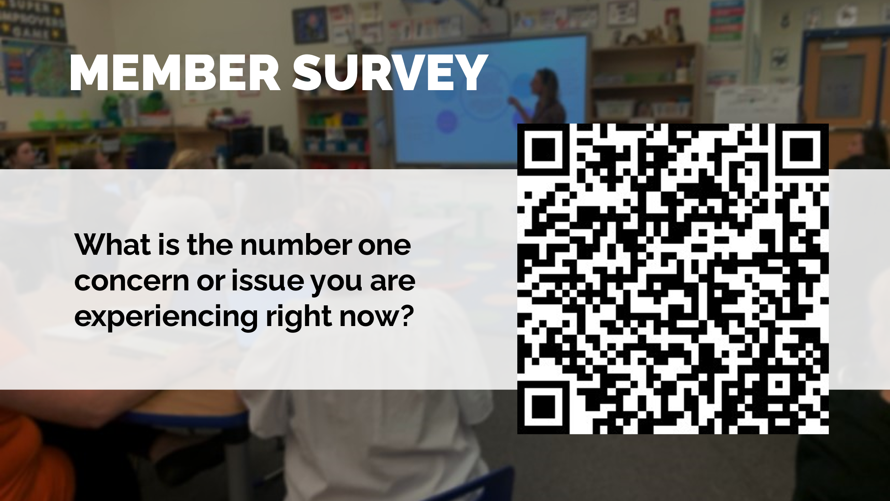 | Slide 4: As our superintendent wants to hear from us, so does union leadership! We are looking for ways to support each other within our schools and across our union, whether on social emotional wellness, or classroom size, or issues with vacancies or how testing is implemented. Any issue you are facing is an issue we can address together. Use this survey to share your thoughts!
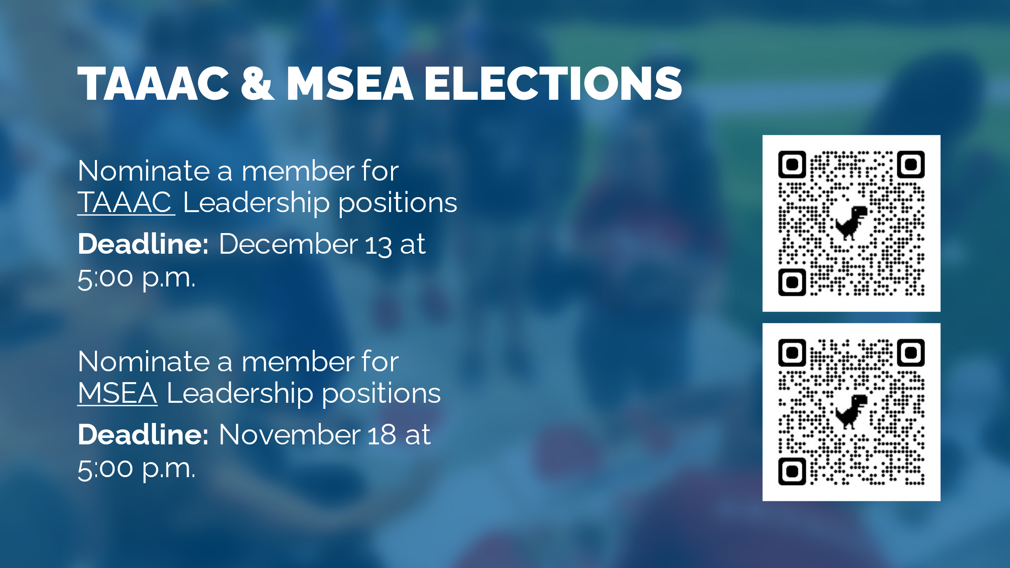 | Slide 5: Next: Union elections are getting started. Nominations are due in two rounds: For TAAAC, nominations are open for Secretary Treasurer, Board of Directors, MSEA and NEA Delegates. They are due December 13 at 5:00 p.m. For our state affiliate, the Maryland State Education Association, nominations are due November 18. Please learn more about the positions and submit names at the qr codes here. Elections will be conducted early 2023.
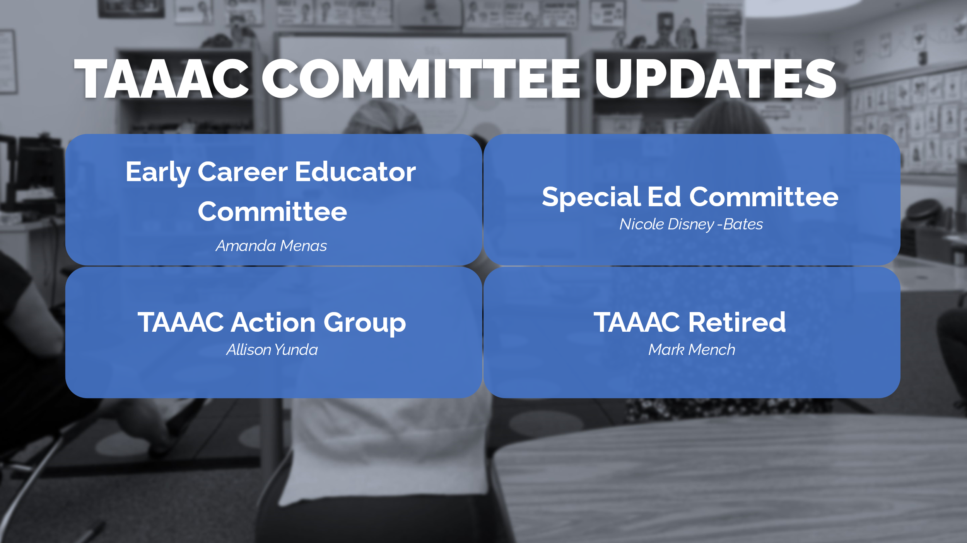 | Slide 6: Finally, a few quick updates for you about TAAAC Committees:  - For those who have been working in the education profession for 5 years or less, stay tuned for a survey from the Early Career Educator committee. They will be hosting a meeting in December and want to know what you need to make the rest of your school year successful.  - The Special Ed committee met last month with the department chairs of Special Education in AACPS last month. Additionally, the Birth-to-Five members will be hosting a meeting later this month.  - The TAAAC Action Group was hard at work getting out the vote for pro-public education candidates during election season, and are now pivoting to lobbying during the legislative session. If you want to make your voice heard about bills that will impact how we teach, the funding that reaches our classrooms, and what the future holds for public education reach out!  - Finally, if you know a TAAAC member who has retired in the last few years, let them know that the TAAAC-Retired committee is hosting a welcome lunch on December 13! There will be a guest speaker session about making your money last in retirement. Additionally, if you are looking to retire in the next few years and have questions yourself stay tuned!  Any member looking to get more involved with any of the committees mentioned here, the staff liaisons are listed on the slides for you to reach out to.
 | Any questions?

