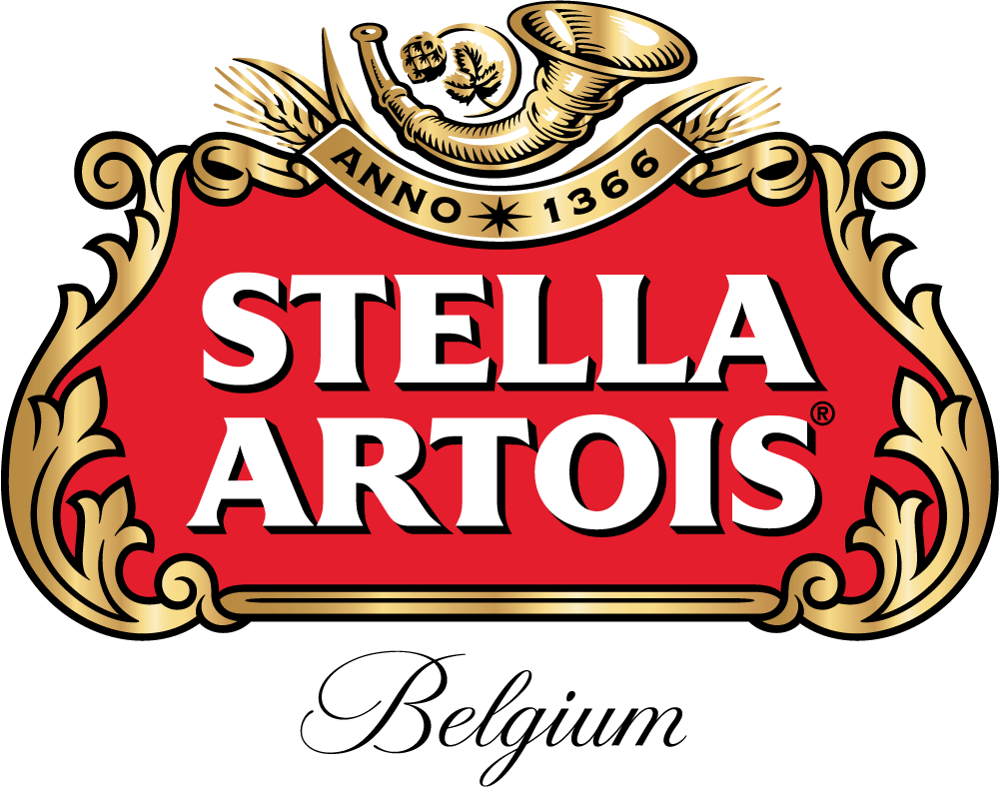
Part time Etchers needed for On Premise
Stella Artois Activations
- $50.00 per hour
- Paid training
- One to two activations per week
- Each activation lasting 2-3 hours
- Must be 21 or older
- Must have a professional appearance and attitude
- Must have nice legible cursive handwriting

Interested parties may contact Penny Fowler at 410-266-1208 or pfowler@capitaleagle.com

